|  |  |
| --- | --- |
| Close-up unopened pill packets  Machine LearninG  Final Project Report  DATS 6202 | Mechanisms of Action(MoA) Prediction using Machine Learning  Purvi Jain  Sanchit Vijay |

**Brief Overview of the Project:**

In this project, we aimed to develop a machine learning model capable of predicting the mechanisms of action (MoA) for various compounds based on their gene expression and cell viability profiles. The dataset used for this project was obtained from the LISH-MoA competition on Kaggle, which contains information on over 23,000 compounds and their effects on various biological targets. We employed four different machine learning algorithms, namely Logistic Regression, Random Forest, and Neural Networks to build our predictive models. The performance of these models was evaluated using the log loss metric, which measures the accuracy of probabilistic predictions.

**1.2 Importance of MoA Prediction in Drug Discovery**

Mechanisms of action prediction plays a crucial role in the drug discovery process, as understanding how a compound interacts with biological targets can provide valuable insights into its potential therapeutic effects and side effects. Accurate MoA predictions can facilitate the selection of promising drug candidates, potentially reducing the time and costs associated with drug development. Moreover, knowledge of a compound's MoA can also aid in the identification of new therapeutic applications for existing drugs, a process known as drug repurposing.

**1.3 Outline of the Report**

The remainder of this report is organized as follows:

Section 2 provides a detailed description of the dataset used in this project.

Section 3 Data Visualization/Exploration

Section 4 describes data pre-processing, model implementation, and performance evaluation.

Section 5 explanation of evaluation metrics, loss function.

Section 6 explains the machine learning algorithms employed including their background information, model summary, and figure.

Section 7 describes the experimental setup.

Section 8 presents the results of the experiments, comparing the performance of the different models, and interpreting the findings.

Section 9 Summary and conclusions.

Section 10 lists the references cited throughout the report.

Section 11 includes an appendix containing documented computer code listings for the project.

**Description of the Dataset**

**2.1 Source: LISH-MoA competition on Kaggle**

The dataset used in this project was obtained from the LISH-MoA competition on Kaggle. This dataset contains gene expression and cell viability data for over 23,000 compounds, along with their mechanisms of action (MoA) annotations.

**2.2 Description of the Data Files**

The dataset is divided into the following data files:

train_features.csv: Contains the gene expression and cell viability data for the training set. It includes 23,314 samples with 876 columns, where the first column represents the unique compound identifier ('sig_id') and the remaining columns correspond to the gene expression and cell viability features.

train_target_scored.csv: Contains the binary MoA annotations for the training set, with one row per compound and one column per MoA.

**2.3 Explanation of the Features**

The features in the dataset can be divided into two categories: gene expression and cell viability.

Gene expression features (g-0 to g-771): These features represent the expression levels of various genes after exposure to the compounds. Higher or lower expression levels indicate the activation or inhibition of specific genes, which can help infer the compound's mechanism of action.

Cell viability features (c-0 to c-99): These features represent the viability of different cell lines after exposure to the compounds. Cell viability is a measure of cell health and can provide insights into the compound's cytotoxicity or potential side effects.

**3. Data Exploration and Visualization**

We investigated the dataset's characteristics using various visualizations. This allowed us to better understand the distribution of features, differences in cell viability between treated and control samples, the impact of treatment time on cell viability, and the correlation between gene expression and cell viability features.

**3.1. For training features**

1. The majority of the treatments in the dataset are compound treatments (referred to as "trt_cp"), while only around 8% are control perturbation treatments (referred to as "ctl_vehicle"). The controls do not have any Mechanisms of Action (MoAs). The "cp_vehicle" column distinguishes between treatment (with drugs) and control (without drugs) experiments.

1. The cp_time column indicates the amount of time elapsed between adding the drug and when the measurement was taken. The effect this has on the data will differ depending on the mechanism. For example, some drugs will have an irreversible effect that can still be seen 72 hours after dosing. Other drugs will have lost all effect by that point and may be indistinguishable from controls.

1. The cp_dose column indicates the dose level used in the experiment. Generally a higher dose will have a stronger effect.

1. We plotted histograms for selected gene expression (g) and cell viability (c) features to observe their distributions. This helped us identify any potential outliers, skewness, or other patterns in the data.

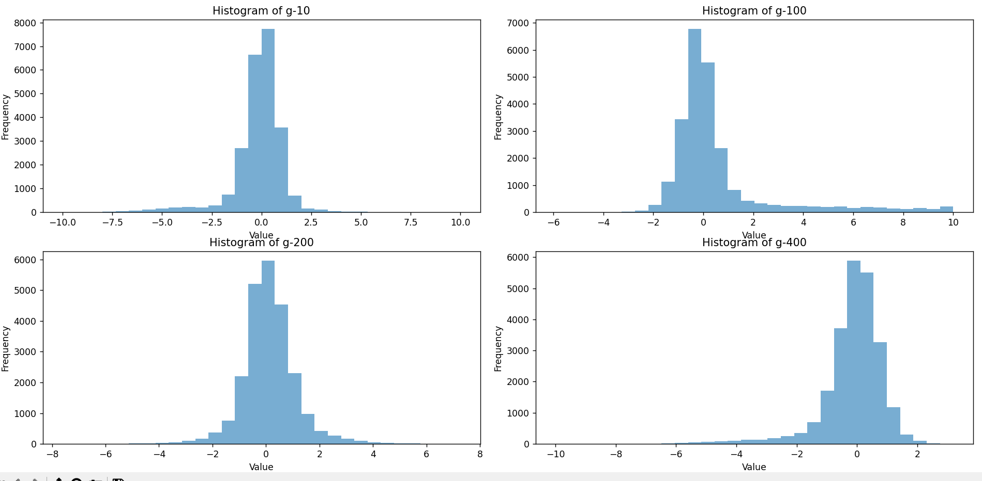

The range of gene expression values is quite wide, spanning from significantly negative to positive values. This demonstrates that the dataset contains genes with varying degrees of activation or inhibition. The gene expression values seem to have a roughly symmetrical distribution around zero, suggesting that many genes have balanced expression levels, with some being upregulated (positive values) and others being downregulated (negative values).

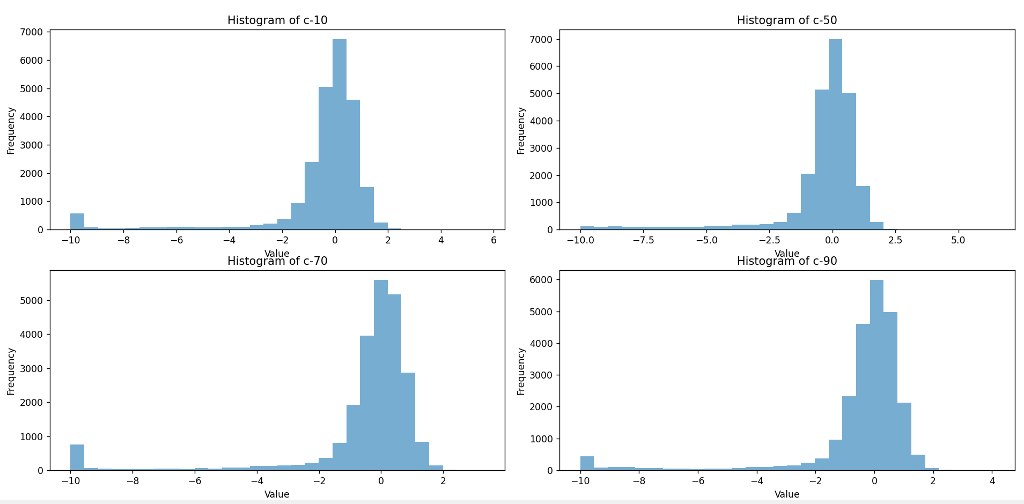

The distributions of the selected c- features appear to be approximately normal (bell-shaped) with some slight deviations. This suggests that cell viabilities in these features follow a common pattern, and extreme values are less frequent. The histograms show that the peak (mode) for each feature is around 0, which could be a result of the data normalization process applied to the dataset. There is a noticeable range in the x-axis values for these features, spanning from around -10 to 6, high negative values indicate a high number of dead cells, while high positive values indicate a high number of living cells

1. We compared the mean cell viability between treated and control samples. This comparison allowed us to identify any significant differences in cell viability due to the presence or absence of treatment.

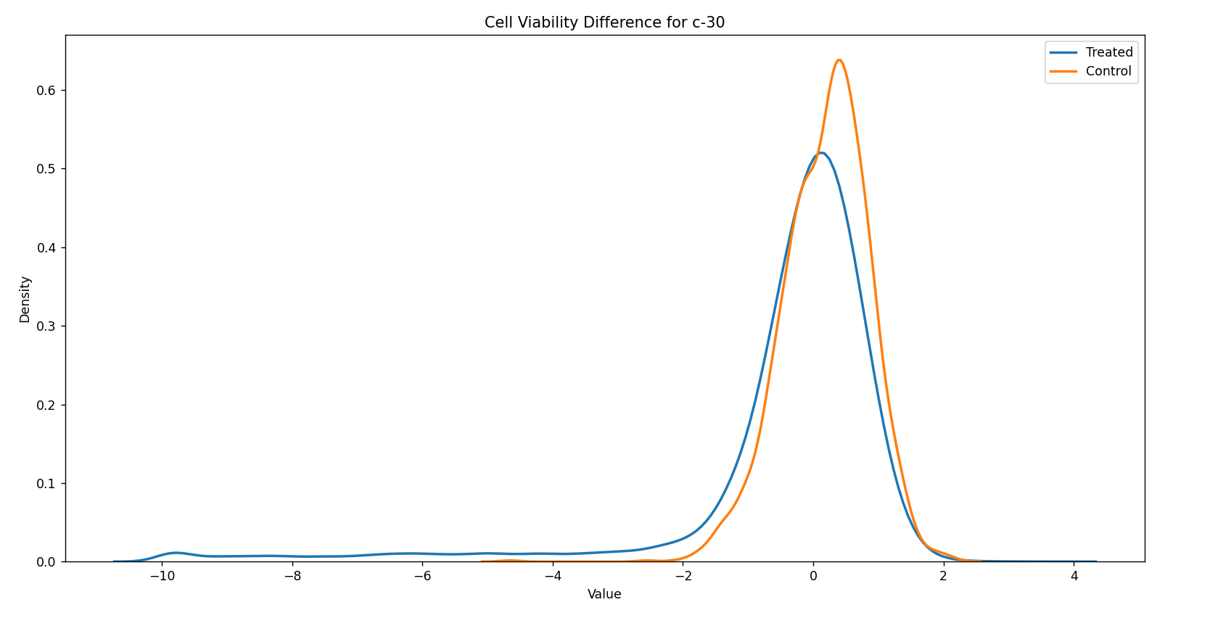

The above KDE plot helps visualize the impact of treatments on cell viability for a specific feature (c-30) by comparing it to control samples. The differences in the distributions provide insights into how various treatments may affect cell viability across samples. The treated samples exhibit a broader and slightly more evenly distributed range of cell viability values compared to the control samples. This indicates that the treatment has a more diverse effect on cell viability in various samples. The control samples show a sharp peak around 0, suggesting that in the absence of treatment, cell viability tends to remain stable and less variable. This suggests that some treatments might have a significant impact on cell viability, causing either an increase in the number of living cells or a decrease leading to cell death.

1. We analyzed the impact of treatment time on cell viability by comparing the mean cell viability at different treatment times (24, 48, and 72 hours). This helped us to determine if treatment duration has any effect on cell viability.

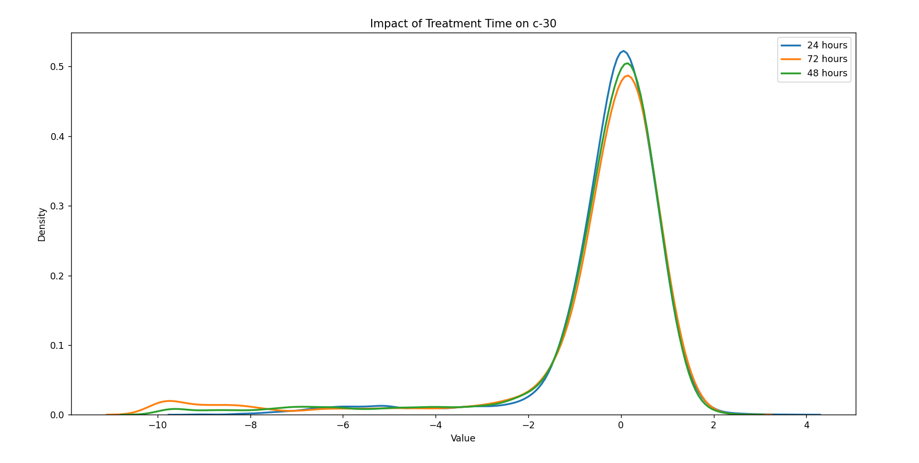

The distribution of cell viability values varies across different treatment durations. This suggests that treatment time has a noticeable effect on cell viability for the selected feature. The plot illustrating the impact of treatment time on cell viability for a specific feature reveals that treatment duration has a considerable influence on cell viability. The observed variability in cell viability values across different treatment times emphasizes the need to account for treatment duration when analyzing the effects of treatments and developing predictive models.

1. We created correlation matrices for gene expression and cell viability features to explore the relationships between these features. This allowed us to identify any strong correlations between features, which could be further investigated for potential feature selection or dimensionality reduction.

The heatmap plot of the correlation between cell viability features in treated samples reveals a wide range of relationships, from strong positive to negative correlations. These correlations provide valuable insights into how cell viability features interact and respond to various treatments, which can help guide future analysis and model development.

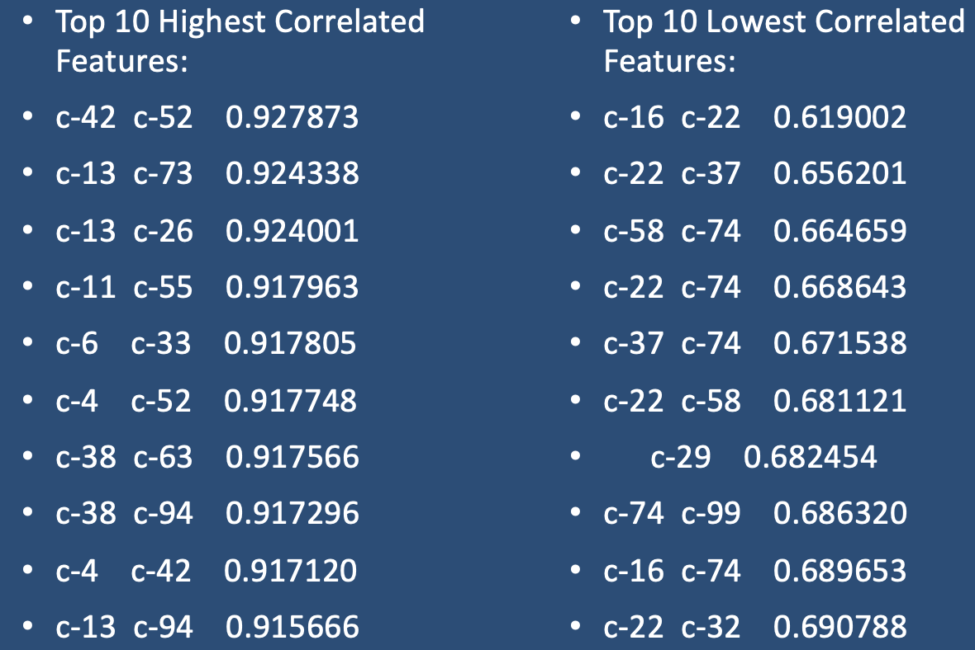

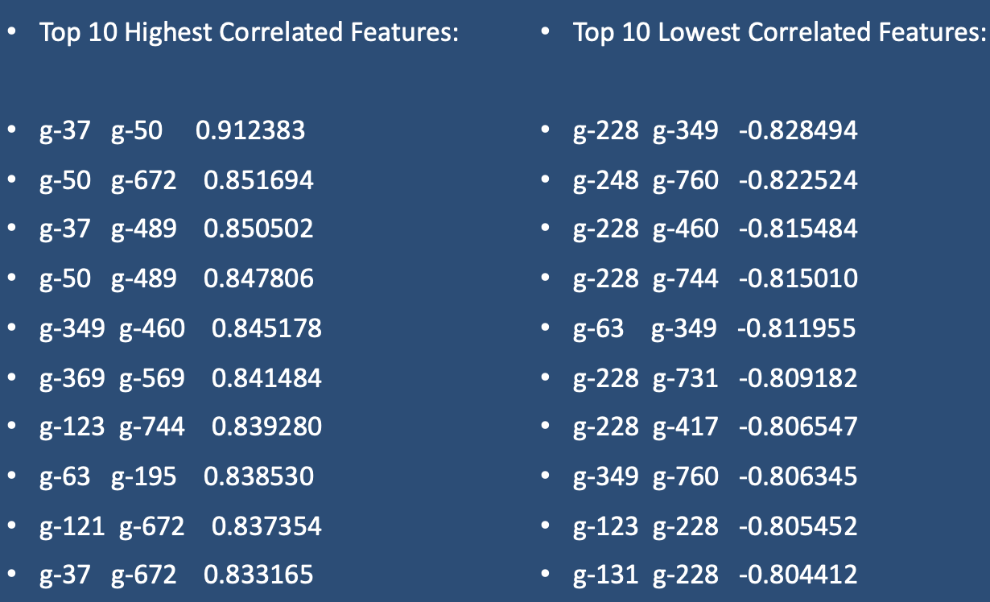

**3.2. For targets**

All the targets are binary columns, indicating whether a certain cell type responds to the drug, or not. Some target classes also measure the type of response; e.g. there is an “adrenergic_receptor_agonist” class and an “adrenergic_receptor_antagonist” class. Those should probably not be active for the same sample row.Our challenge is a multi-label classification problem, and as such the rows (i.e. drug samples) can have multiple MoA’s (i.e. more than one target class can be active).

1. About 39% of training samples have no MoA annotations at all (e.g. all the target classes have values of zero). This goes a certain way to explain the sparse target dataframe, if 40% of it are completely empty, these are controlled perturbations (here). The largest group, with a bit more than 50% of samples, has exactly 1 MoA annotation (e.g. one class = one value of “1” in its row). For more than 1 MoA annotation, we see a tail that extends down to 7 simultaneous MoAs (for 0.03% of cases). Only the case of 2 MoAs is just above 5%, and 3 MoAs is slighly above 1%. Every other case is significantly rarer. Note, that there is no instance with 6 MoAs.

1. It seems we have 2 outliers here: "nfkb_inhibitor” and “proteasome_inhibitor”.

1. Correlation between targets. Most of the targets have 0 correlation. It is worth recalling that the presence of active targets in the samples in very low (mainly 1 or 2 targets per sample).

1. 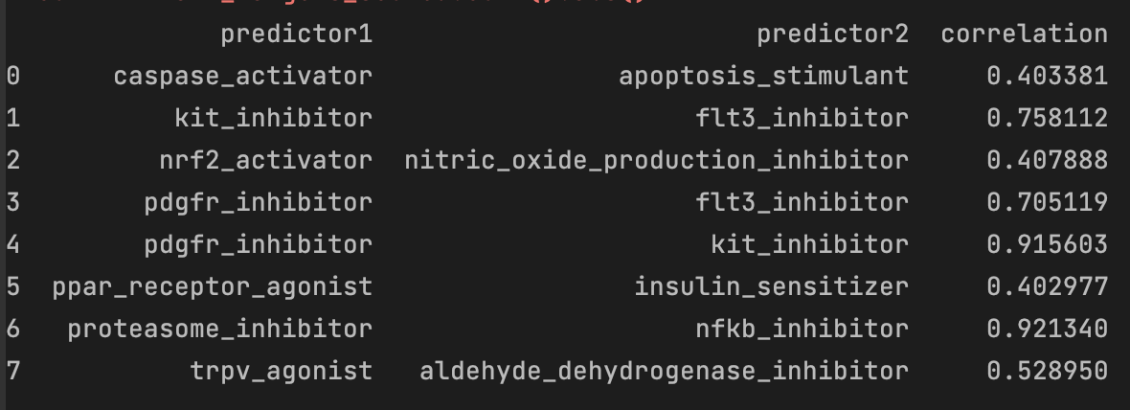we notice some yellow dots (high correlation) between some targets. Let's have a closer look over these targets.

In this multi-label classification problem, we need to consider the targets that have more than two active targets as they are important for the model's functionality and distribution. We should also take into account the correlation between the labels when selecting a model. Therefore, it is important to choose a model that can identify patterns not only in the training data but also in the multi-label target data.

By exploring and visualizing the data, we gained valuable insights into the dataset's structure and relationships, which can inform our future modelling decisions and improve our understanding of the underlying biological processes.

**4. Data Pre-processing Steps**

Before training the machine learning models, the following pre-processing steps were performed on the dataset:

**4.1. For classic ML algorithms**

Merging the data: The train_features and train_target_scored datasets were merged on the "sig_id" column.

Separating categorical columns: The categorical columns 'cp_type', 'cp_time', and 'cp_dose' were separated from the numerical columns for preprocessing.

Standardizing the numerical data: The gene expression data was standardized using the RobustScaler. This ensures that all gene expression features are on a similar scale and prevents any one feature from dominating the model's predictions.

Dimensionality reduction using PCA: Principal Component Analysis (PCA) was applied to the gene expression data, reducing the dimensionality while retaining 95% of the variance in the data. This step helps visualize the dataset and potentially speeds up the machine learning algorithms.

Merging the preprocessed data: The scaled gene expression data, cell viability data, and one-hot encoded categorical data were merged into a single dataset.

Splitting the data: The data was split into training and validation sets using an iterative stratification approach with an 80-20 ratio, which ensures that the distribution of MoA annotations in both sets is similar.

Scaling and dimensionality reduction on the entire dataset: The merged dataset was then scaled using the RobustScaler, and PCA was applied to reduce dimensionality while retaining 95% of the variance in the data.

**4.2. For NN algorithm**

Variance thresholding is performed. It is used in multilabel classification to deal with highly correlated features that may be redundant and add noise to the model. By removing features with low variance, we reduced redundancy, noise, and irrelevant features that were negatively affecting the model's performance.

We performed PCA on gene expressions and cell viability data separately. PCA is essentially a rotation of the parameter space so that the new axes are orthogonal and align with the directions of maximum variance. We extracted the 50 features from gene data that were explaining the variance and 15 features from cell data.

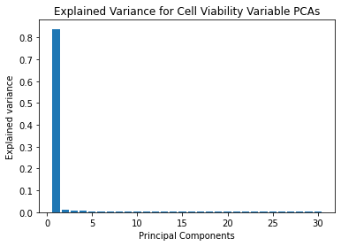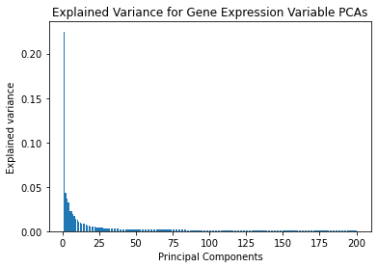

**5. Loss Function**

We are using log-loss or cross-entropy loss for our loss function in this classification model. This type of loss function is used to measure the performance of a classification model that outputs a probability value between 0 and 1. The reason for using cross-entropy loss is that it measures the difference between multiple probabilities for a given set of events.

While accuracy measures the number of correct predictions, it only provides a binary result of correct or incorrect, and thus has its limitations. In contrast, log loss or cross-entropy loss takes into account the level of uncertainty in the prediction by measuring how much it differs from the true label, providing a more nuanced and detailed evaluation of the model's performance.

[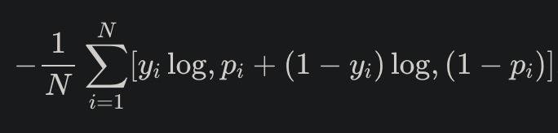](https://datawookie.dev/blog/2015/12/making-sense-of-logarithmic-loss/)

where N is the number of samples or instances, M is the number of possible labels, y*ij* is a binary indicator of whether or not label j is the correct classification for instance i, and p*ij* is the model probability of assigning label j to instance i.

**6. Machine Learning Algorithms**

In this study, three machine learning algorithms were employed to predict the mechanism of action (MoA) of the compounds: Logistic Regression, and Random Forest.

**6.1 Logistic Regression**

Logistic Regression is a linear statistical model used for binary classification tasks. It is an extension of the linear regression model for classification purposes. The logistic function, also known as the sigmoid function, is applied to transform the output into probabilities that sum to 1. These probabilities can then be used to predict the class labels.

**6.2 Random Forest**

Random Forest is an ensemble learning method that combines multiple decision trees to make predictions. The algorithm creates multiple trees, each trained on a random subset of the training data and averages their predictions. This approach reduces overfitting and improves the model's generalization performance.

**6.3 Neural Networks**

The neural network architecture consists of multiple fully connected layers, with batch normalization and dropout layers for regularization. The loss function used is binary cross-entropy, and the model is trained using the Adam optimizer.

Batch normalization (BN) is a technique utilized in neural networks to normalize the inputs of each layer in a mini-batch during the training phase. For a multilabel classification problem, BN can enhance the model's performance by minimizing the internal covariate shift that can happen during training. The internal covariate shift refers to the modification of the distribution of inputs to a layer during training, owing to the changing parameters of the previous layers. This may cause the model to take longer to converge or overfit to the training data. BN normalizes the inputs to each layer, maintaining the distribution of inputs constant across layers and training batches, to address this issue. This can lead to quicker convergence and better generalization to new data. By introducing these layers before the dense layers, we can make sure that the model is regularized and generalizes well to new, unseen data. Below figures show our NN model:

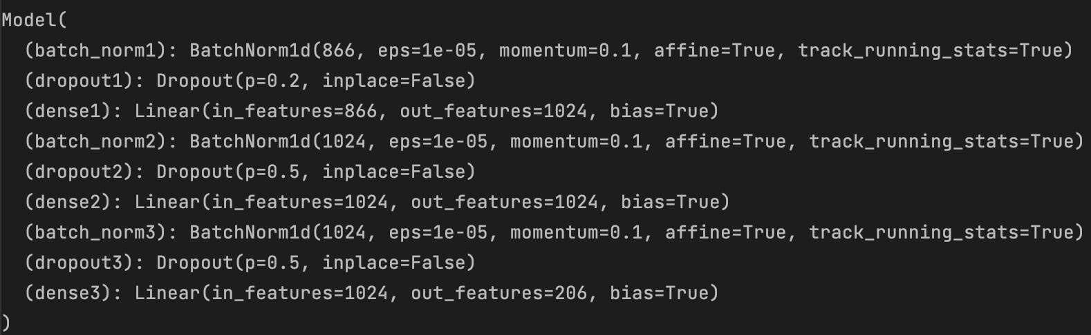

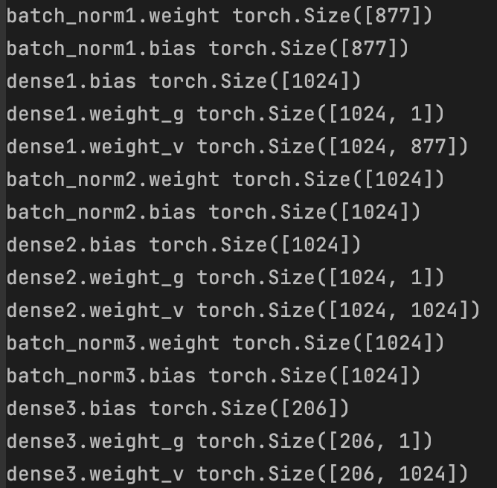

**7. Experimental Setup**

The experimental setup involves several key steps, including data splitting, feature scaling, dimensionality reduction, performance evaluation, and code organization.

**7.1 Data Splitting**

The dataset is split into training and validation sets using an iterative stratification approach, which helps in maintaining the class distribution across the splits. The iterative_train_test_split function from the skmultilearn.model_selection library is employed for this purpose, with 80% of the data used for training and 20% for validation.

For training neural networks Multilabel Stratified K-Fold is used. It is a cross-validation technique specifically designed for multilabel classification problems. It uses stratified sampling to ensure that each fold has the same distribution of labels as the entire dataset. This ensures that the performance evaluation of the model is not biased towards any particular label combination, and that the model is generalizable to all possible label combinations. In essence, Multilabel Stratified K-Fold helps to improve the robustness and generalizability of the model by ensuring that the label distribution is consistent across all folds during cross-validation.

**7.2 Feature Scaling**

Feature scaling is performed using the RobustScaler from the sklearn.preprocessing library. This method is less sensitive to outliers, as it scales the features using the interquartile range (IQR) instead of the mean and standard deviation. The RobustScaler is fit on the training data and then applied to both the training and validation sets.

**7.3 Dimensionality Reduction**

Dimensionality reduction is performed using Principal Component Analysis (PCA) from the sklearn.decomposition library. PCA is a technique that transforms the data into a new coordinate system with orthogonal axes, which helps in reducing the number of features while retaining most of the variance in the data. In this study, PCA is configured to retain 95% of the explained variance.

**7.4 Model Training and Evaluation**

We have demonstrated the process of training and evaluating the three classic machine learning algorithms. The dataset is first split into training and validation sets using an iterative stratification approach. Then, the MultiOutputClassifier is applied to each base model to handle the multi-label classification problem. Each model is trained using the fit method, and the predictions are made using the predict_proba method if available or the predict method otherwise. Finally, the log loss is calculated for each model to evaluate its performance.

**8 Results**

The performance of the three machine learning models (Logistic Regression, Random Forest, and Neural Network) is evaluated on the validation set using the logit loss metric. The results are compared across different models to identify the best-performing model.

**8.1 Comparison of the Results Across Different Models**

A comparison of the log loss values indicates that the neural network with pre-processing that includes dimensionality reduction and merging with original features followed by variance thresholding model performs the best on the validation set, with the lowest log loss value of 0.015065 among all the models.

**8.2 Interpretation of the Results**

The log loss metric is used to evaluate the performance of the classification models. Lower log loss values signify better model performance. The comparison of the results suggests that the neural network model provides the most accurate predictions among the tested models for this specific dataset. In summary, the difference in performance of the three models can be attributed to their ability to capture non-linear relationships between the input features and the target variable. Linear models like logistic regression assume a linear relationship between the input features and the target variable, while tree-based models like random forest can capture non-linear relationships to some extent. Neural networks, on the other hand, can learn highly non-linear relationships between the input features and the target variable, which makes them more suitable for complex tasks. They can also learn hierarchical representations of the data through their hidden layers, making them well-suited for complex problems. The correlation between the labels is also important. Neural network is able to find patterns not just in the train data but also in the multi-label target data. So NN is best performing model here.

**8.3 Tables and Figures to Support the Results**

|  |  |
| --- | --- |
| Model | Log Loss |
| Logistic Regression | 4.750906931715915 |
| Random Forest | 0.64373824828473726 |

|  |  |
| --- | --- |
| Model | Cross Validation Log-Loss |
| Neural Network (NN) | 0.015141795107179487 |
| NN with Variance Threshold | 0.015134272041324904 |
| NN with PCA (50+15) | 0.015497931941619792 |
| NN with PCA & Original Features (OF) | 0.01507352052049503 |
| NN with PCA & OF & Variance Threshold | 0.015065720776652382 |

The table clearly shows the log loss values for each model, making it easy to compare their performance on the validation set. The NN with PCA & OF & Variance Threshold model has the lowest log loss value, indicating better performance compared to the other models.

Above plot shows validation curve while training for 5 folds for best model.

**9 Summary and Conclusions**

**9.1 Recap of the Main Findings**

This study aimed to predict cellular responses to different drugs using three machine learning models: Logistic Regression, Random Forest, and Neural Networks. The dataset was pre-processed, and dimensionality reduction was applied using PCA. The performance of each model was assessed using the log loss metric on the validation set. The main findings of the study are:

The neural network model exhibited the best performance among the three models, with the lowest log loss value.

**9.2 Lessons Learned from the Project**

The project demonstrated the importance of data pre-processing, feature scaling, dimensionality reduction, and model evaluation in building and comparing machine learning models. It also showed that different models may perform differently on the same dataset, underscoring the need to try multiple models to identify the best-performing one.

**9.3 Suggestions for Future Improvements**

There are several potential avenues for improving the predictive performance of the models:

Better feature engineering: Investigating and creating more informative features could lead to improved model performance. Trying more advanced models: Exploring deep learning models or other advanced machine learning techniques could yield better results. Exploring ensemble techniques: Combining the predictions of multiple models can often lead to more accurate predictions.

**10 References**

<https://lincsproject.org/>

<https://clue.io/connectopedia/glossary>

<https://www.nature.com/articles/s43018-019-0018-6>

<https://www.sciencedirect.com/science/article/pii/S0092867417313090?via%3Dihub>

Cross Validation: <https://www.kaggle.com/competitions/lish-moa/discussion/195195>

PCA: <https://www.kaggle.com/c/lish-moa/discussion/195888>

<https://www.kaggle.com/code/headsortails/explorations-of-action-moa-eda#dimensionality-reduction-via-pca>

Loss: <https://www.kaggle.com/code/ikennaanigbogu/understanding-logloss/notebook>

<https://datawookie.dev/blog/2015/12/making-sense-of-logarithmic-loss/>

**11 Appendix**

**11.1 Documented Computer Code Listings**

<https://www.kaggle.com/code/kokitanisaka/moa-ensemble#Two-Headed-NN>

<https://www.kaggle.com/code/thehemen/pytorch-transfer-learning-with-k-folds-by-drug-ids>

<https://www.kaggle.com/code/headsortails/explorations-of-action-moa-eda#dimensionality-reduction-via-pca>

<https://www.kaggle.com/code/datafan07/mechanisms-of-action-what-do-we-have-here/notebook#Correlations>

**11.2 Description of the Functions and Their Usage**

**MoADataset**

The `MoADataset` class is a custom dataset class in PyTorch used for loading data for training or inference.

The class takes in `features` and `targets` arrays as input and initializes them as instance variables.

The `__len__` method returns the length of the `features` array.

The `__getitem__` method takes an index (`idx`) as input and returns a dictionary containing the input and target data for that index. The input data is converted to a PyTorch float tensor and stored in the `'x'` key of the dictionary, while the target data is also converted to a PyTorch float tensor and stored in the `'y'` key of the dictionary. This class is used to create a PyTorch DataLoader which can then be used to iterate over the dataset in batches during training or inference.

Train function:

Train the PyTorch model on the given data using the provided optimizer, scheduler, and loss function.

Parameters:

model: the PyTorch model to be trained

optimizer: the optimizer to be used for updating model parameters

scheduler: the learning rate scheduler

loss_fn: the loss function to be optimized

dataloader: the data loader containing the training data

device: the device to be used for training (CPU or GPU)

Returns:

epoch_loss: average loss of the epoch